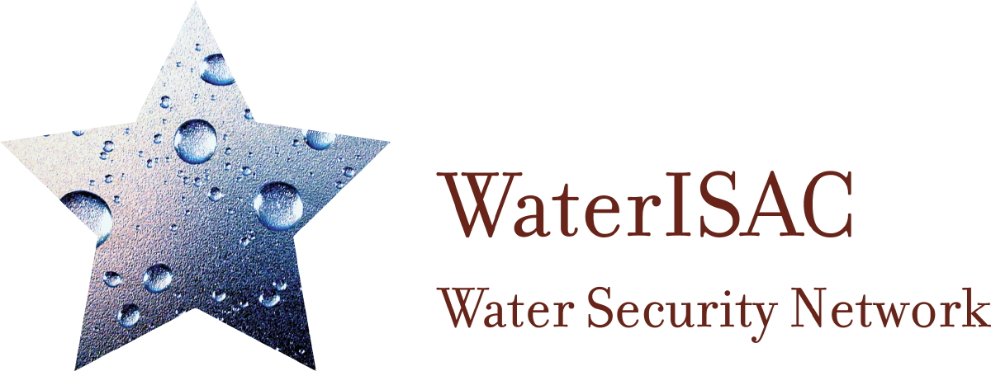

Webcast Title: Black Sky Hazards and Water Sector Resilience
Webcast Date: January 23, 2018, 2pm EST
Webcast Length: 60 minute

Overview
The webinar featured Dr. Paul Stockton, a well-regarded expert on disaster preparedness and the implications of extended power outages. Stockton will discuss how Black Sky power outages - outages lasting a month or more and affecting multiple states - could turn a natural or manmade disaster into a catastrophe. He also addressed resilience measures and provided insight into the factors that water and wastewater utilities might consider in order to maintain minimal service levels during Black Sky outages.

Nicholas Santillo, VP Internal Audit & Chief Security Officer for American Water, provided an overview of water sector activities related to Black Sky planning.

The webinar also featured Lauren Wisniewski, an environmental engineer with the U.S. Environmental Protection Agency’s Water Security Division. Wisniewski provided an overview of EPA’s Power Resilience Guide. She also discussed upcoming EPA and sector activities focused on Black Sky outages and resilience.

The event was co-hosted by WaterISAC and the National Association of Water Companies.

Moderator: Donald Schumacher, Superintendent of Operations, Connecticut Water

Goals/Objectives
- To describe Black Sky hazards
- To inform participants about current water sector initiatives related to Black Sky mitigation
- To discuss available resources that support Black Sky mitigation

Course materials and related materials
The PowerPoint presentation, webinar recording and resources mentioned during the webinar are available at www.waterisac.org/blacksky.

Agenda
- Introduction
- Black Sky Hazards and Water Sector Resilience (Dr. Paul Stockton)
- Water Sector Activities (Nicholas Santillo)
- Power Resilience and Black Sky Planning at Water Utilities (Lauren Wisniewski)
- Question and Answer Session (Stockton, Santillo, Wisniewski)
- Resources (WaterISAC staff)
- Conclusion

Presenters (see included bios)

Dr. Paul Stockton
Managing Director
Sonecon, LLC
202 393-2228

Dr. Paul Stockton is the Managing Director of Sonecon, LLC and former Assistant Secretary of Defense for Homeland Defense. He is also the author of the Electric Grid Protection Handbook II, Volume II: Water Sector Resilience for Black Sky Events. As Assistant Secretary, Dr. Stockton oversaw DOD’s responses to Superstorm Sandy, Deepwater Horizon and other incidents and also guided the Defense Critical Infrastructure Protection program. Dr. Stockton has been twice awarded the Department of Defense Medal for Distinguished Service and is also a recipient of the Department of Homeland Security’s Distinguished Public Service Medal.

Nicholas Santillo, CPP, PSP, PCI
VP Internal Audit & Chief Security Officer
American Water
856-310-5705
nick.santillo@amwater.com

Nick Santillo is the Vice President of Internal Audit & Chief Security Officer at American Water. He currently serves on the Water Sector Coordinating Council representing the National Association of Water Companies, and he is a member of the WaterISAC Board of Managers. He is also the current Chair of the ASIS Utilities Security Council and the Water Sector Chair of the Electric Infrastructure Security Council working on Black Sky Planning.

Lauren Wisniewski, MPH
Environmental Engineer
U.S. EPA, Water Security Division
202-564-2918
wisniewski.lauren@epa.gov

Lauren Wisniewski has worked as an environmental engineer in U.S. EPA’s Office of Water since 2002. Her efforts have focused on power resilience at water utilities, Multi-Sector Infrastructure Protection, Climate Ready Water Utilities, Active and Effective Security, Water Quality Standards, and watershed modeling. And her work has involved coordination between drinking water and wastewater utilities and state, local, and federal agencies.

About the Water Information Sharing and Analysis Center (WaterISAC)
WaterISAC’s mission is to provide water and wastewater utilities and the federal, state, and local government agencies responsible for water security with the information and tools needed to prevent, detect, respond to, and recover from all hazards.

WaterISAC is:

- The designated official communications/operations arm of the Water Sector Coordinating Council
- Authorized by the U.S. Congress
- A 501(c)(3) formed in 2002
- Overseen by a board of utility managers and state drinking water administrator

Contact:
Michael Arceneaux
WaterISAC
1620 I Street, NW, Suite 500
Washington, DC 2006
www.waterisac.org
202-331-0479
info@waterisac.org

Presenter Bios

Dr. Paul Stockton

Dr. Paul Stockton is the Managing Director of Sonecon, LLC and former Assistant Secretary of Defense for Homeland Defense. He is also the author of the Electric Grid Protection Handbook II, Volume II: Water Sector Resilience for Black Sky Events. As Assistant Secretary, Dr. Stockton oversaw DOD’s responses to Superstorm Sandy, Deepwater Horizon and other incidents and also guided the Defense Critical Infrastructure Protection program. Dr. Stockton has been twice awarded the Department of Defense Medal for Distinguished Service and is also a recipient of the Department of Homeland Security’s Distinguished Public Service Medal.

Nick Santillo, Jr.

Nick Santillo is the Vice President of Internal Audit & Chief Security Officer at American Water. He currently serves on the Water Sector Coordinating Council representing the National Association of Water Companies, and he is a member of the WaterISAC Board of Managers. He is also the current Chair of the ASIS Utilities Security Council and the Water Sector Chair of the Electric Infrastructure Security Council working on Black Sky Planning.

Lauren Wisniewski

Lauren Wisniewski has worked as an environmental engineer in U.S. EPA’s Office of Water since 2002. Her efforts have focused on power resilience at water utilities, Multi-Sector Infrastructure Protection, Climate Ready Water Utilities, Active and Effective Security, Water Quality Standards, and watershed modeling. And her work has involved coordination between drinking water and wastewater utilities and state, local, and federal agencies.

